**Satellite Image Segmentation using SAMGeo and Leafmap**

Python, Data Science, [Meta SAM 2](https://ai.meta.com/sam2/)

**Vamshi Samudrala**

**January 14, 2025**

Link to Project: [Satellite Image Segmentation](https://colab.research.google.com/drive/17lY7X_Zr7fBq-QVHh51i2ELe16SZufwE?usp=sharing)

**Table of Contents**

1. Project Overview
2. Prerequisites:
3. Creating Interactive Map
4. Drawing Region of Interest (ROI)
5. **Initializing the SAMGeo Model**
6. Automatic Mask Generation
7. Visualizing Object Annotations
8. Image Comparison Using a Slider
9. Add image to the map
10. Advanced Mask Generation
11. Conclusion
12. Next Steps
13. Time Consumption

### **Project Overview**

This project focuses on segmenting **buildings** from satellite imagery using the **Segment Anything Model (SAM)**. SAM is a state-of-the-art image segmentation model developed by Meta, designed to provide **zero-shot segmentation** capabilities, which means it can segment objects in images without the need for retraining on task-specific data. This makes SAM highly versatile for applications such as **building detection**, especially in geospatial datasets.

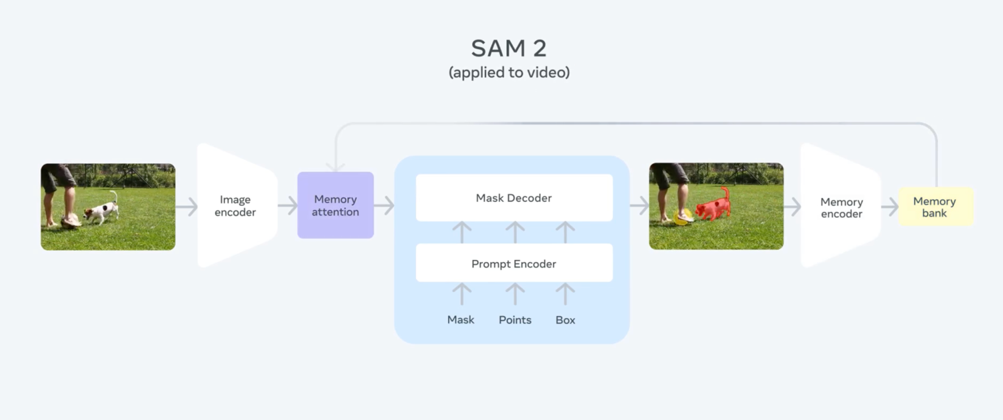

Prerequisites:

1. **Python Environment**
   * Install Python 3.7 or later. You can download it from [python.org](https://www.python.org/).
2. **Jupyter Notebook or Google Colab**
   * **Jupyter Notebook**: Install Jupyter Notebook to create and execute Python scripts locally. You can install it using the following command:
   * pip install notebook
   * **Google Colab**: Alternatively, you can use Google Colab, a free, browser-based environment for running Python code. It requires no installation and comes pre-configured with many libraries.

### Steps to Open Google Colab and Start a New Notebook

1. **Open your web browser**: Launch the web browser of your choice
2. **Search for Google Colab**:
   * In the search bar, type **"Google Colab"** and press **Enter**.
   * Alternatively, you can directly visit [Google Colab](https://colab.research.google.com/).
3. **Log in to your Google Account**:
   * If you're not already logged in, click the **Sign In** button located at the top right corner of the page.
   * Enter your **Google credentials** (email and password) to log in.
4. **Create a New Notebook**:
   * Once logged in, click on the **"File"** menu located at the top left.
   * From the dropdown, select **"New notebook"** to create a fresh notebook.

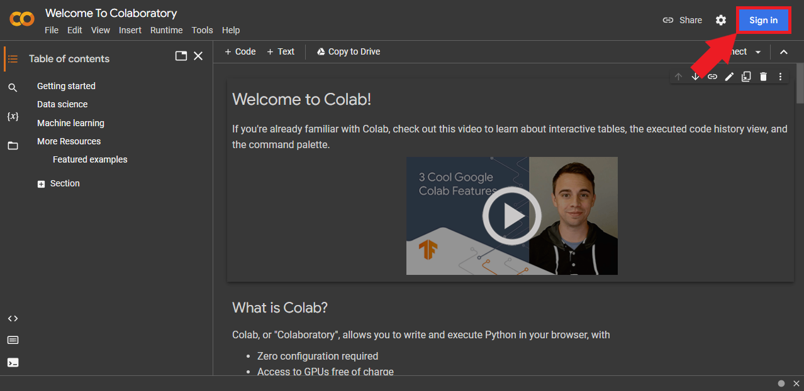

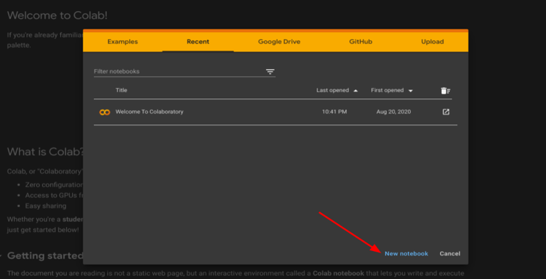 or 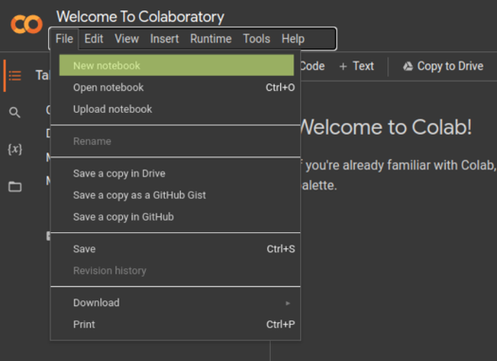

1. **Required Libraries**
   * Install the necessary Python libraries using the following command:

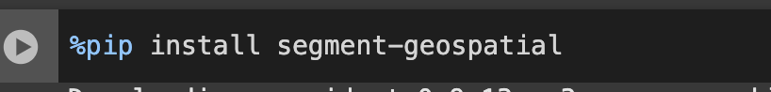

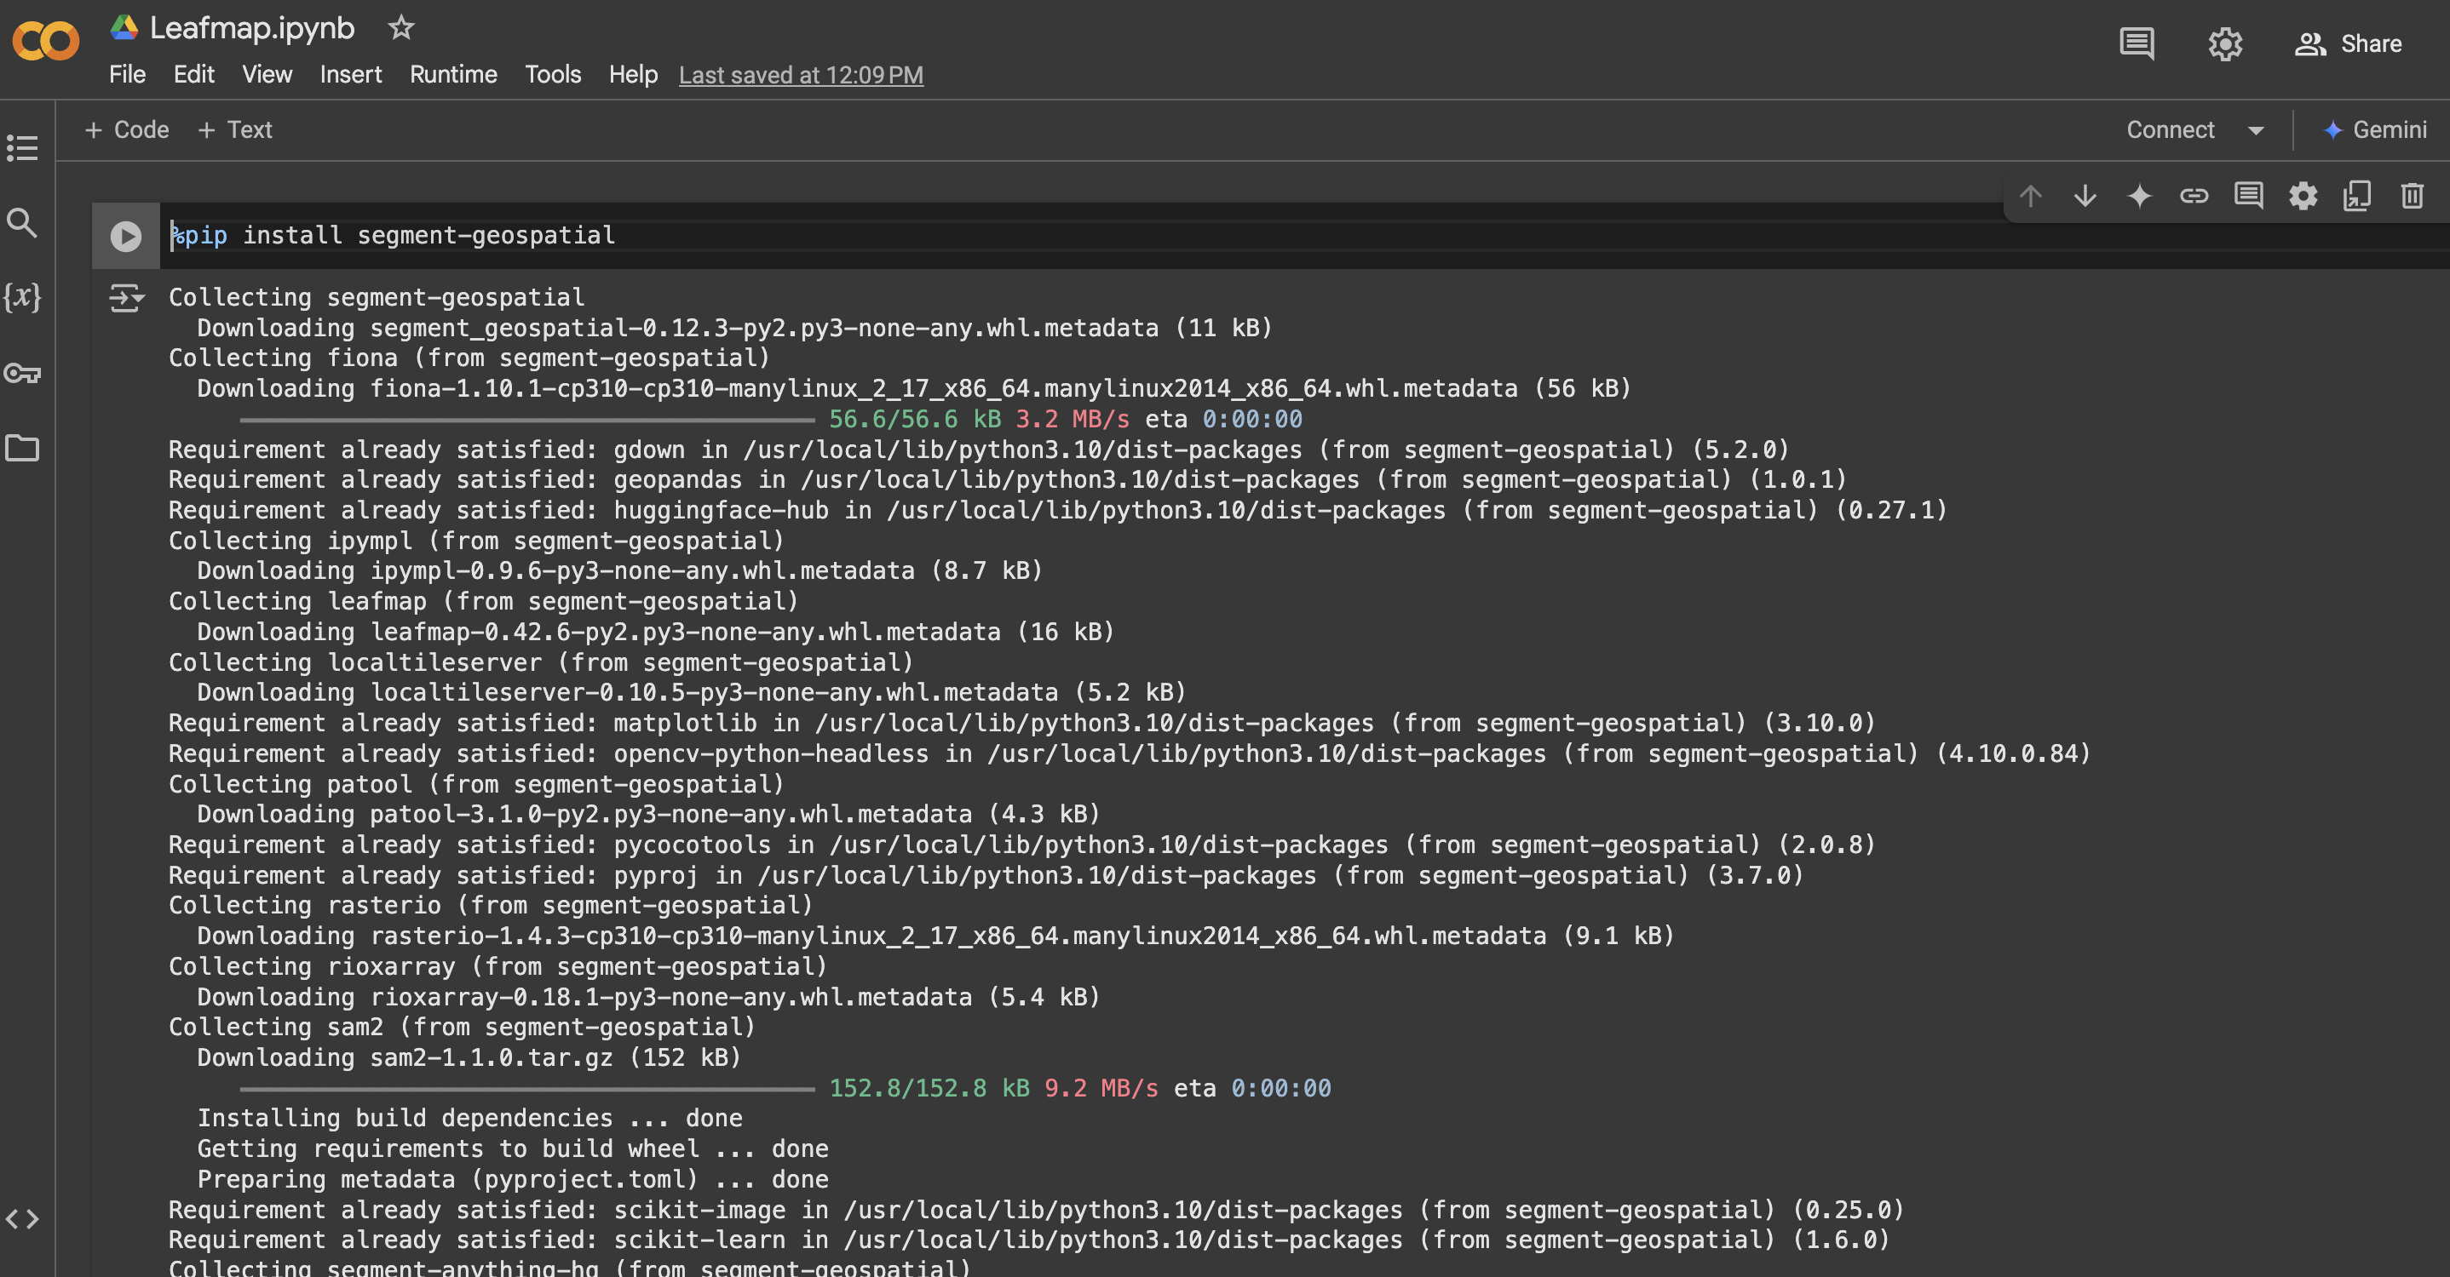

### 

leafmap, samgeo

### **Creating the Interactive Map**

We will use leafmap to create an interactive map, allowing us to view and select the region of interest (ROI) on the satellite image.



**Explanation:**  
The map is centered at coordinates (12.9716, 77.5946) with a zoom level of 17 and a satellite basemap. Use the draw tools to select an area of interest on the map.

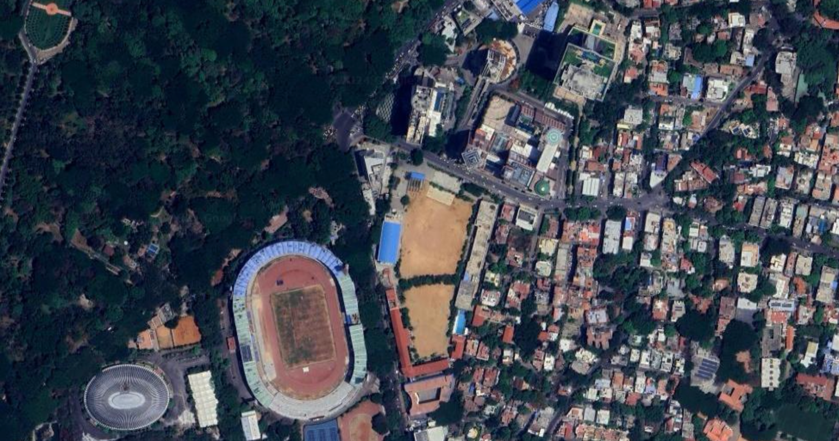

### **Drawing the Region of Interest (ROI)**

After selecting the area on the map, you can either manually draw a polygon/rectangle or use a predefined bounding box.

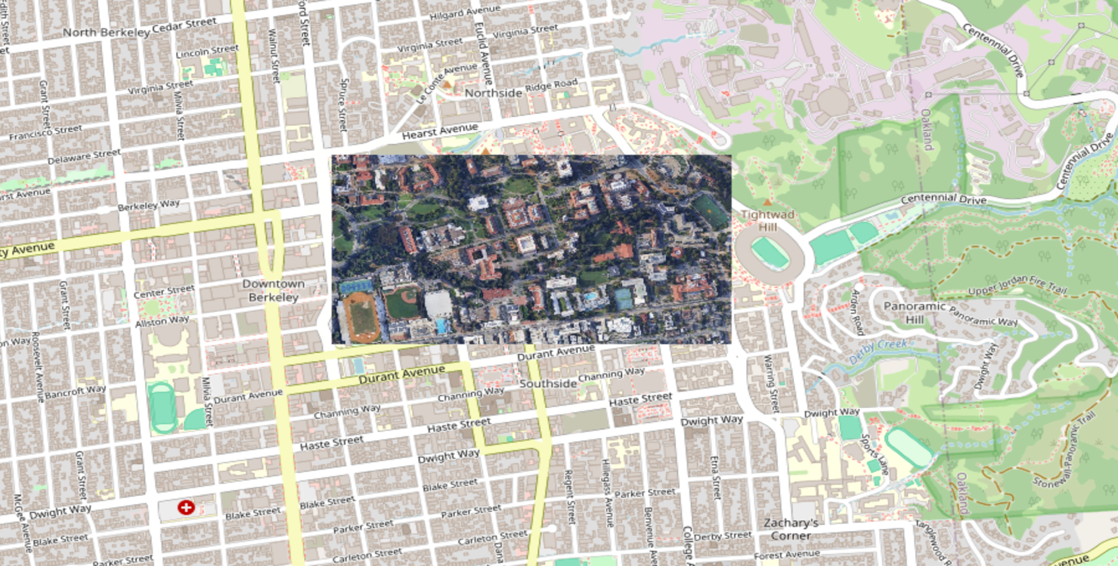

**Explanation:**  
This step captures the bounding box of the selected area (ROI). If the user doesn’t manually select a region, a default bounding box is used.

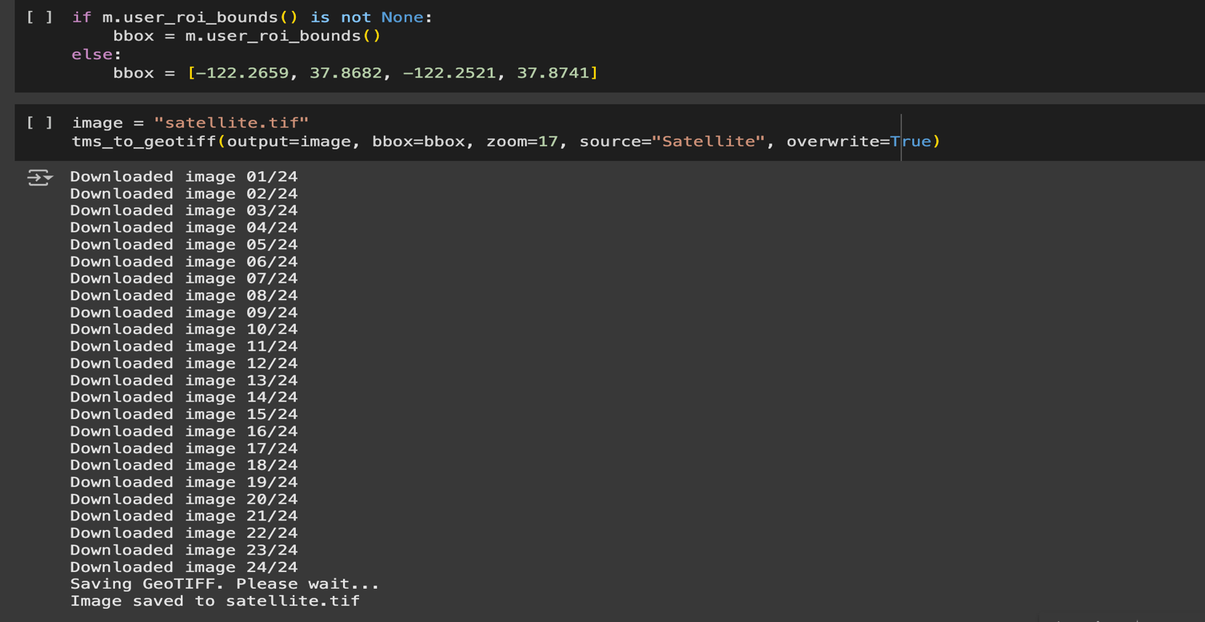

### **Initializing the SAMGeo Model**

Before segmentation, we initialize the SAMGeo model, specifying its configuration.



**Explanation:**  
The SAMGeo model is initialized with the vit_h version (Vision Transformer) for segmentation.

### **Automatic Mask Generation**

We can now segment the image using the SamGeo model. The generated masks will be saved as masks.tif.



**Explanation:**  
This step segments the image and displays the result using a binary color map to highlight the segmented areas.

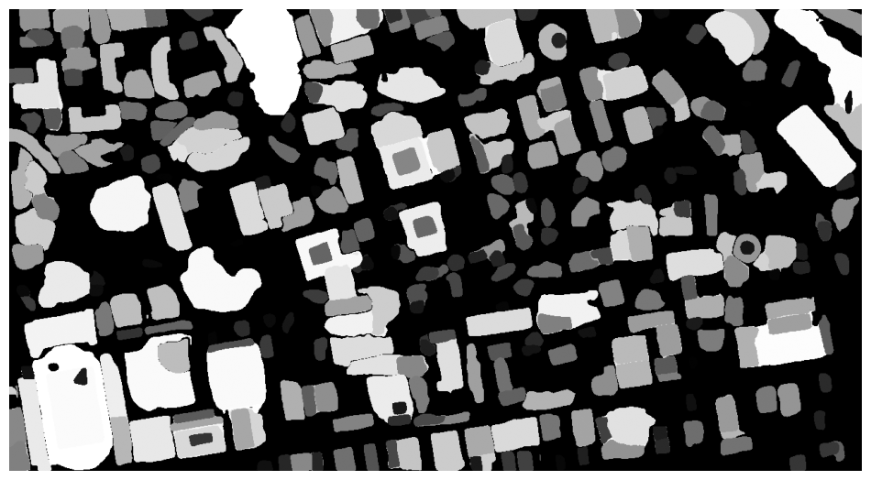

Visualizing Object Annotation

We can visualize the object annotations (identified objects) by overlaying them on the image.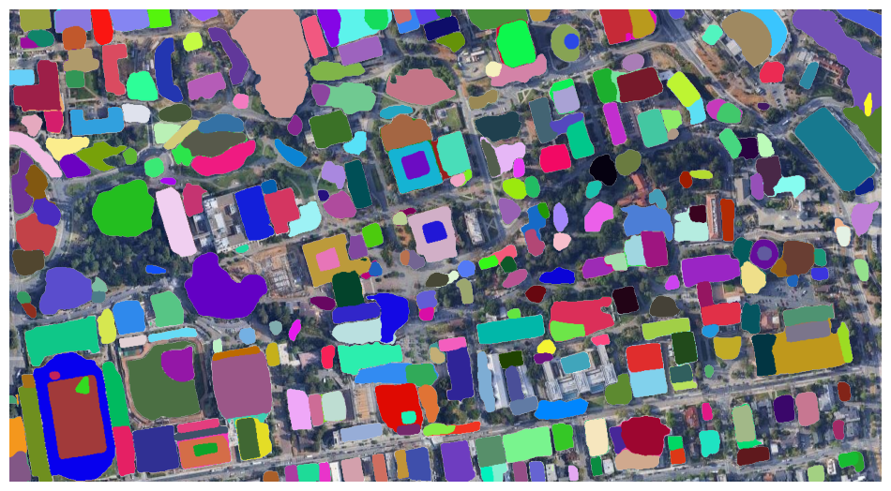

### **Image Comparison Using a Slider**

To compare the original satellite image with the segmented annotations, we use the Leafmap image comparison slider.

Add image to the map



Next, we overlay the object annotations on the map to visualize the segmentation results.

### **Advanced Mask Generation Options**

For more refined mask generation, you can adjust the model's parameters.

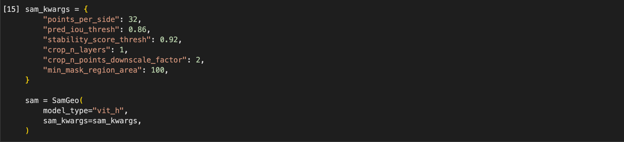

### **Advanced Mask Generation**

### We now generate masks using the advanced settings, which are saved as masks2.tif.



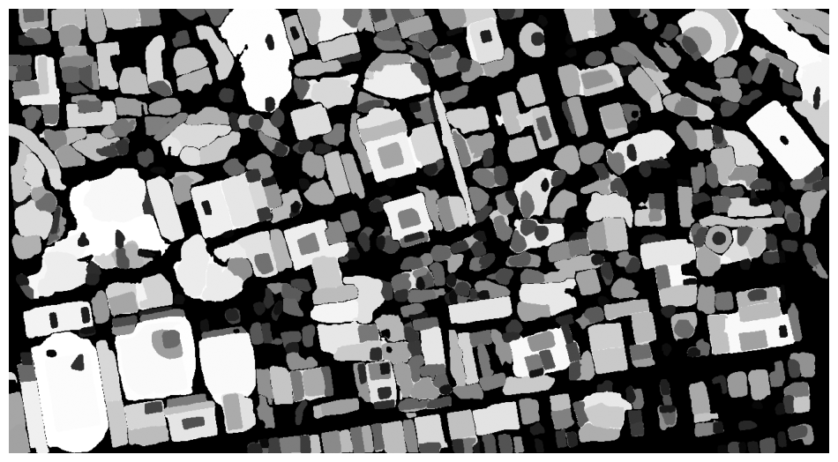

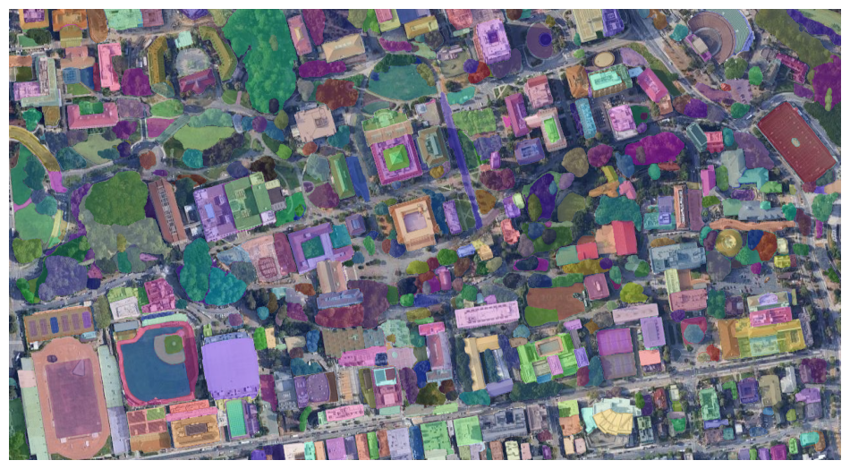





### **Conclusion**

This tutorial demonstrated how to use SAMGeo and Leafmap for satellite image segmentation. The segmentation results were visualized, and the accuracy was evaluated. Future work could focus on optimizing the segmentation process for better performance on smaller objects and testing with different model configurations.

### **Next Steps**

1. **Building Detection and Counting**
   * Use the SAMGeo model to detect and count buildings in satellite images.
   * Generate masks with unique IDs to segment and count individual buildings accurately.
2. **Integration with Building-Specific Features**
   * Utilize additional spectral indices or spatial filters to enhance building detection.
   * Apply post-processing techniques to filter out non-building objects.
3. **Validation and Accuracy Assessment**
   * Validate detected buildings using ground truth data, such as cadastral maps or verified datasets.
   * Calculate accuracy metrics like precision, recall, and IoU to evaluate the model's performance.
4. **Advanced Applications**
   * Conduct urban growth studies by analyzing building footprints over time.
   * Use detected buildings for infrastructure planning, disaster management, and land-use analysis.
5. **Visualization and Reporting**
   * Create visualizations overlaying detected buildings on satellite imagery.
   * Provide detailed reports with object counts, coverage statistics, and spatial patterns.
6. **Future Enhancements**
   * Fine-tune the SAMGeo model for building-specific datasets.
   * Explore additional models or ensemble methods to improve segmentation accuracy.

### Time Spent on the Project

* **Total Time Taken to Complete the Project**: Approximately **9 hours**
* **Time Consumed for Running the Code**: Approximately **4 hours**
* **Time to Run Notebook for New Image**: Approximately **1 hour** on a normal computer with **8 GB RAM**